

SMART STAR EXAMINATIONS BOARD

**BEGINNING OF TERM I EXAMINATION – 2024**

P.3 LITERACY 1B

***Time allowed: 2hrs 15minutes***

NAME____________________________________STREAM________

SCHOOL_________________________________________________

**SECTION A (40 MARKS)**

1. What is a school?

_________________________________________________________

2. Which animal guards our home?

_________________________________________________________

3. **Draw this item found in our classroom.**

|  |
| --- |
|  |
| **book** |

4. Which part of a house protects us from bad weather?

_________________________________________________________

5. Why do we need a school nurse in a school?

_________________________________________________________

6. Mention any two means of air transport.

i)________________________________________________________

ii)_______________________________________________________

7. What do we call the sending and receiving of messages?

_________________________________________________________

8. Which colour of the traffic lights tells drivers to stop?

________________________________________________________

9. Why do you come to school?

_________________________________________________________

10. **Name the sources for these materials.**

clay _________________________________________________

stones _________________________________________________

11. Write any two people who keep peace and security in the community.

(i) _____________________________________________________

(ii) _____________________________________________________

12. Why do we come to school?

_________________________________________________________

13. Where do we put utensils after washing?

_________________________________________________________

14. Who is a pedestrian?_____________________________________

________________________________________________

15. Mention any two things used in recreation centres.

(i) _______________________________________________________

(ii) ______________________________________________________

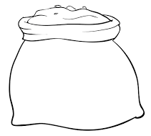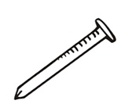16. Name these building materials.



_____________________ _____________________________

17. Which element of weather dries our clothes?

_________________________________________________________

18. What title is given to a person who heads a school?

_________________________________________________________

20. Which basic need makes us healthy?

_________________________________________________________

21. What do we call a building where we ease ourselves from?

_________________________________________________________

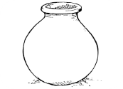22. How important is the item below at home?

___________________________________________

23. Draw any one thing used to keep our classroom clean.

24. Write any one example of furniture?

_________________________________________________________

25. What are crafts?

_________________________________________________________

_________________________________________________________

26. Why do we stand straight while singing the school anthem?

_______________________________________________________

27. How are humps important on the road?

_________________________________________________________

28. According to the Bible, who brought the good news to Mary?

___________________________________________________

29. Who is the grandfather of all believers?

_________________________________________________________

30. Mention any one source of water.

_________________________________________________________

31. **Name this road sign.**



___________________________________

32. How important are ropes to school children?

_________________________________________________________

33. Who heads prayers in a mosque?

________________________________________________________

34. Jesus spent _______________________ days in the tomb.

35.Who brought the Good News to Mary according to the Bible?__________________________________________________

36. What does the name Esau mean?

________________________________________________________

**SECTION B (60 MARKS)**

37. What do we call the time people set a break after work or studies?

_________________________________________________________

(b) Mention two cultural initiation ceremonies.

(i) ______________________________________________________

(ii) ______________________________________________________

c) On which day do we celebrate Heroes’Day?

________________________________________________________

d) How important are holidays to a P.2 child?

_______________________________________________________

38. Write any two examples of children’s rights.

(i) _______________________________________________________

(ii) _____________________________________________________

b) Mention one form of child abuse.

_________________________________________________________

c) **Draw these children’s needs.**

|  |  |
| --- | --- |
|  |  |
| **clothes** | **food** |

39. **Match correctly;**

black smith builds houses

welder makes things out of iron

potter makes things out of metal

carpenter makes things out of clay

builder makes things out of wood

40. **Study the picture below.**

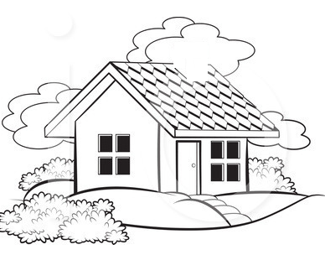

b

c

a) Name part marked.

b ____________________________________________________

c ____________________________________________________

b) How important is a window to a house?

______________________________________________________

c) Write any two things found in a kitchen.

i) _____________________________________________________

ii) ______________________________________________________

41. **Draw and name three things used to keep peace and security**.

|  |  |  |
| --- | --- | --- |
|  |  |  |
|  |  |  |

b) Write two factors that show there is Peace and Security athome.

(i) _______________________________________________________

(ii) ________________________________________________________

42. How is a television useful in your community?

________________________________________________________

43. How do we enter God’s family?

_________________________________________________________

b) Write two holy books in the Bible.

(i) ________________________________________________________

(ii) _________________________________________________________

c) Name any two things God created.

(i) _________________________________________________________

(ii) ________________________________________________________

**END**